6. Writing SQL queries to filter and sort data from single table.

Create a Table
create table employees(
id int primary key,
name varchar(100),
department varchar(50),
age int,
salary decimal(10,2)
);
select*from employees;
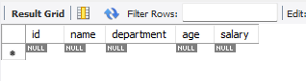

Insert some sample data
insert into employees (id,name,department,age,salary)values
(1,'gauri','hr',22,70000),
(2,'bhavana','it',28,55000),
(3,'neha','hr',25,40000),
(4,'hisha','it',27,30000),
(5,'diya','finance',30,36000);
select*from employees;

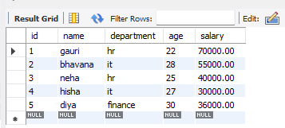

Filter Records using WHERE
select*from employees
where department='it';

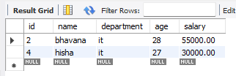

Sort Records using Order by
select*from employees
order by salary desc;

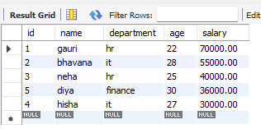

Combine Filtering and Sorting
select*from employees
where age>22
order by age asc;

